COOPERATIVE FINANCIAL TRANSACTION MANAGEMENT SYSTEM
INTRODUCTION
Background of the Study
Financial cooperative societies, commonly known as Savings and Credit Cooperative Organizations (SACCOs), play an important role in providing financial services such as savings, loans, and investments to their members. As membership and transaction volumes continue to grow, these organizations require efficient systems to manage financial records accurately, securely, and efficiently (Cormen et al., 2022; Goodrich et al., 2014).
Many cooperatives still rely on manual processes or outdated computerized systems, which often result in slow transaction processing, duplicate records, delayed loan approvals, and difficulties in retrieving financial information. These challenges reduce operational efficiency and affect the quality of service provided to members (Weiss, 2013).
Modern financial management systems address these issues by using efficient data structures and algorithms to improve data storage, transaction processing, and system performance. Data structures such as hash tables, trees, queues, stacks, and heaps enable faster data retrieval, transaction validation, loan prioritization, and secure record management while supporting system scalability (Cormen et al., 2022; Goodrich et al., 2014).
This project proposes a Cooperative Financial Transaction Management System (FinCoop) that integrates these advanced data structures and algorithms to improve the speed, accuracy, and reliability of financial operations. The system aims to provide efficient transaction management, prevent duplicate records, support secure data processing, and enhance decision-making through reliable financial information. Ultimately, the proposed system demonstrates how modern computing techniques can improve the performance and scalability of cooperative financial management systems (Weiss, 2013; Cormen et al., 2022).

Problem Statement
Problem Statement
The existing cooperative financial transaction management systems face several challenges that reduce their efficiency, reliability, and scalability. These challenges include:
- Slow transaction processing: As the number of members and financial transactions increases, many systems become slower due to inefficient methods of storing and retrieving data, leading to longer processing times and reduced productivity.
- Inefficient transaction retrieval: Retrieving member records and transaction histories from large datasets often takes longer than expected, making it difficult for staff to access information quickly and provide timely services.
- Duplicate transaction records: Weak transaction validation mechanisms may allow duplicate entries, resulting in inaccurate financial records, inconsistencies, and potential financial losses.
- Delayed loan processing: Many cooperative systems lack an effective mechanism for prioritizing loan applications, causing delays in approvals and reducing member satisfaction.
- Poor scalability: Traditional systems are unable to efficiently handle rapidly growing datasets, resulting in slower system performance, increased response times, and higher resource consumption.
- Limited error recovery mechanisms: Existing systems often lack effective rollback or recovery features, making it difficult to reverse incorrect transactions and increasing the risk of data corruption.
- Difficulty in generating structured reports: Producing financial summaries, transaction reports, and member statements can be time-consuming when data is not organized efficiently.
- Security and data integrity concerns: Inadequate controls for transaction validation and data management may expose the system to unauthorized modifications, data inconsistencies, and loss of financial information.
- Need for an improved solution: To address these challenges, there is a need for a secure, scalable, and efficient Cooperative Financial Transaction Management System that utilizes advanced data structures and algorithms, such as hash tables, trees, queues, stacks, and heaps, to improve transaction processing speed, enhance data retrieval, prevent duplicate transactions, prioritize loan applications, and ensure reliable financial management.

Objectives of the Study
General Objective
The general objective of this study is to design and develop a secure, efficient, and highly scalable Cooperative Financial Transaction Management System that utilizes advanced data structures and algorithms to improve the processing, storage, retrieval, and management of financial transactions within cooperative societies. The system seeks to enhance operational efficiency by minimizing transaction processing time, preventing data duplication, supporting accurate financial record management, and ensuring that the system remains reliable and responsive even when handling large volumes of financial data. Additionally, the proposed system aims to provide an effective platform for managing member accounts, loan processing, transaction histories, and financial reporting while maintaining data integrity, security, and optimal algorithmic performance.
Specific Objectives
The study aims to achieve the following specific objectives:
- To design and develop a secure financial transaction management system that provides an efficient platform for recording, storing, updating, and managing cooperative financial transactions while ensuring data confidentiality, integrity, and availability through appropriate security mechanisms.
- To implement high-speed transaction search and retrieval capabilities using hash tables in order to achieve near constant-time lookup performance, allowing users to quickly access member accounts, transaction records, and financial information regardless of the size of the database.
- To detect and systematically prevent duplicate financial transactions by implementing efficient transaction validation mechanisms that verify transaction identifiers before processing, thereby improving data accuracy, reducing inconsistencies, and preventing financial losses.
- To prioritize loan processing workflows using min/max binary heaps so that loan applications can be efficiently organized and processed according to predefined priority criteria such as urgency, eligibility, repayment history, or approval policies, resulting in fair and timely loan allocation.
- To support secure transaction undo and rollback operations using stack data structures to enable the recovery of recently executed transactions in cases of user errors, processing failures, or system interruptions, thereby maintaining transaction consistency and improving system reliability.
- To enable structured multi-level reporting using hierarchical tree structures for organizing financial records in a logical hierarchy that supports efficient report generation, transaction categorization, and analysis of financial data across different organizational levels.
- To improve the scalability and overall performance of the system by integrating efficient algorithms capable of processing large volumes of financial transactions while maintaining fast response times, low memory usage, and high computational efficiency.
- To improve decision-making within cooperative societies by providing accurate, timely, and well-structured financial information that supports management in monitoring financial activities, evaluating member accounts, and making informed operational decisions.
Scope of the Study
This study focuses on the design and development of a Cooperative Financial Transaction Management System intended to improve the efficiency of financial operations within cooperative societies. The system is designed to manage essential financial activities while demonstrating the practical application of advanced data structures and algorithms in solving real-world transaction management challenges.
The scope of the study includes the following functional areas:
- Member registration and account management, including the creation, updating, and maintenance of member profiles and financial records.
- Recording and management of financial transactions such as deposits, withdrawals, loan disbursements, loan repayments, and account balance updates.
- Processing and tracking of loan applications, including loan approval workflows and prioritization using binary heap data structures.
- Fast retrieval of transaction records and member information through the implementation of hash tables for efficient searching and indexing.
- Detection and prevention of duplicate financial transactions using transaction validation techniques to ensure data consistency and integrity.
- Implementation of stack-based rollback mechanisms that allow administrators to reverse recent transactions in cases of processing errors or accidental operations.
- Generation of structured financial reports using hierarchical tree structures to organize transaction records, summarize financial activities, and support management reporting.
- Evaluation of system performance based on algorithm efficiency, scalability, processing speed, memory utilization, and suitability for handling increasing transaction volumes.
Despite covering these major functionalities, the study has several limitations. The proposed system does not include integration with commercial banking systems, mobile money platforms, online payment gateways, external clearing house networks, or government financial regulatory systems. It also does not implement real-time interbank fund transfers, automated tax processing, biometric authentication, or cloud-based deployment. Furthermore, the system is developed primarily for academic purposes to demonstrate the effective use of data structures and algorithms in cooperative financial transaction management rather than serving as a fully operational enterprise financial system. Therefore, additional enhancements would be required before deployment in a real-world production environment.
ALGORITHM AND DATA STRUCTURE DESIGN
System Architecture and Flow
The FinCoop Cooperative Financial Transaction Management System is designed using a layered architecture that promotes modularity, scalability, maintainability, and security. Layered system architecture separates the application into distinct functional components, making it easier to maintain, upgrade, and extend as organizational requirements evolve (Bass et al., 2022; Sommerville, 2016).
The architecture begins with the Client Interface Layer, where users such as administrators, accountants, loan officers, and cooperative members interact with the system. Through this interface, users perform activities including member registration, deposits, withdrawals, loan applications, transaction inquiries, and report generation. Input validation is performed before requests are forwarded to the business logic layer (Pressman & Maxim, 2020).
The Business Rules Processing Engine forms the core of the application. This layer implements algorithms responsible for transaction validation, duplicate detection, authentication, authorization, financial calculations, and loan prioritization. Every transaction submitted through the user interface is processed according to predefined business rules before it is committed to the database (Sommerville, 2016).
Below the business logic is the Data Structures Layer, which is responsible for organizing, storing, and retrieving financial records efficiently. Specialized data structures such as arrays, linked lists, queues, stacks, hash tables, balanced binary search trees, and heaps are integrated to optimize different financial operations while minimizing computational complexity (Goodrich et al., 2014; Cormen et al., 2022).
The final layer consists of the Database Management System, where validated member information, financial transactions, loan records, reports, and audit logs are stored permanently. The database ensures data consistency, integrity, security, and recovery while supporting simultaneous access by multiple users (Elmasri & Navathe, 2017).
The layered architectural design improves software maintainability, scalability, reliability, and flexibility by ensuring that each component performs a specific responsibility independently while communicating efficiently with other system components (Bass et al., 2022).
CORE DESIGN FOCUS: HASH TABLE IMPLEMENTATION AND EXPANSION
Introduction
The hash table is the primary data structure adopted within the FinCoop system because of its exceptional performance in searching, inserting, and validating financial transactions. Modern financial information systems require extremely fast processing speeds to support thousands of concurrent transactions while maintaining high levels of accuracy and reliability. Hash tables satisfy these requirements by providing an average-case computational complexity of O(1) for insertion, searching, updating, and duplicate detection operations (Cormen et al., 2022).
Each financial transaction is assigned a unique transaction identifier that serves as the hash key. A carefully selected hash function transforms the transaction identifier into a numerical array index where the transaction record is stored. This approach eliminates the need for sequential searching and significantly reduces transaction retrieval time, even when the system manages millions of records (Goodrich et al., 2014).
To address situations where multiple transaction identifiers generate identical hash values, the system implements Separate Chaining as its collision resolution strategy. Each bucket within the hash table maintains a singly linked list that stores all records mapped to the same index. This technique ensures that collisions are handled efficiently without compromising overall system performance (Cormen et al., 2022).
Before a transaction is permanently recorded, the system immediately searches the hash table to determine whether an identical transaction already exists. If a duplicate transaction identifier is detected, the transaction is rejected before reaching the database. This validation mechanism prevents duplicate postings, maintains financial accuracy, protects member balances, and enhances data integrity throughout the transaction lifecycle (Weiss, 2013).
The implementation of hash tables therefore enables the FinCoop system to process large transaction volumes with minimal response times while supporting scalability, reliability, and efficient resource utilization (Goodrich et al., 2014).

System Constraints
The design of the FinCoop system is guided by several functional and performance constraints to ensure that it can operate efficiently under real-world cooperative financial environments.
- Large-scale transaction handling: The system is designed to efficiently manage more than 1,000,000 financial transaction records without significant degradation in performance. This ensures that the application remains suitable for both small and large cooperative societies.
- Fast transaction lookup: The system must provide near real-time transaction retrieval by utilizing efficient searching techniques such as hash tables, achieving an average lookup time of O(1) for transaction identification and validation.
- Memory efficiency: The selected data structures should minimize unnecessary memory consumption while supporting efficient allocation and deallocation of storage space. This improves overall system performance and reduces computational overhead.
- Concurrent transaction processing: Since multiple users may access the system simultaneously, the system should support thread-safe operations to maintain data consistency and prevent conflicts during concurrent transaction processing.
- Duplicate transaction prevention: Every financial transaction must have a unique transaction identifier. The system should automatically validate transaction identifiers before processing to eliminate duplicate entries and maintain accurate financial records.
- Scalability: The system architecture should support future expansion in terms of increasing numbers of members, accounts, and financial transactions without requiring major redesign or affecting system performance.
- Reliability and data integrity: The system should ensure that all financial operations are executed correctly, preserving the consistency, accuracy, and integrity of financial data even in the event of processing errors or unexpected system failures.
Data Structure Selection and Justification
The FinCoop system employs several specialized data structures, each selected based on its ability to efficiently perform specific financial management tasks.
Array
Arrays provide simple sequential storage for transaction records and other structured information. They allow direct access to elements using index positions, making them suitable for storing relatively static datasets. Although arrays offer fast element access, they have limited flexibility because their size is fixed after allocation. Consequently, arrays are mainly used for temporary storage and report generation rather than dynamic transaction management.
Linked List
Linked lists are used to maintain dynamic transaction histories where records are frequently inserted or deleted. Unlike arrays, linked lists do not require contiguous memory allocation, making them highly flexible for handling continuously growing transaction records. This enables efficient updating of member transaction histories while minimizing memory reallocation.
Queue (FIFO)
Queues follow the First-In, First-Out (FIFO) principle and are used for processing incoming financial transactions in the order they are received. This ensures fairness during transaction processing by preventing newly submitted transactions from bypassing earlier requests. Queues are also suitable for managing transaction requests waiting to be processed by the system.
Stack (LIFO)
Stacks operate according to the Last-In, First-Out (LIFO) principle and are used to implement transaction rollback and undo functionality. Whenever a transaction is executed, its previous state is temporarily stored in the stack. If an error occurs or an administrator needs to reverse the operation, the most recent transaction can be restored quickly and efficiently. This improves system reliability and supports recovery from processing errors.
Hash Table
The hash table is the primary data structure within the FinCoop system. It enables extremely fast searching, insertion, and retrieval of transaction records using unique transaction identifiers as keys. Under normal operating conditions, hash tables provide an average lookup complexity of O(1), making them highly suitable for financial systems that require immediate transaction validation and duplicate detection. The use of hash tables significantly reduces processing delays and improves the overall responsiveness of the system.
Balanced Binary Search Tree (BST)
Balanced Binary Search Trees organize transaction records in sorted order, allowing efficient searching, insertion, deletion, and range queries. This structure is particularly useful for generating chronological transaction reports, retrieving records within specified date ranges, and producing ordered financial statements. Maintaining a balanced tree ensures that search operations remain efficient even as the number of stored records increases.
Heap (Priority Queue)
Binary heaps are used to prioritize loan applications based on predefined evaluation criteria such as urgency, repayment history, member eligibility, or loan priority score. The heap structure ensures that the highest-priority loan application can be retrieved efficiently without sorting the entire dataset. This improves fairness, speeds up loan processing, and enhances resource allocation within the cooperative society.
Overall, the combination of these data structures enables the FinCoop system to achieve efficient transaction processing, rapid data retrieval, secure financial record management, structured reporting, and scalable performance capable of supporting the operational needs of modern cooperative societies.

Insert Transaction Algorithm
1. Check the primary Hash Table for existing Transaction ID to evaluate duplicates.
2. If not duplicate, insert transaction record into underlying Array storage.
3. Append to the Linked List history ledger.
4. Map Transaction ID → Data reference in the Hash Table.
5. Append the task context to the Queue for asynchronous background processing.
Complexity Analysis Summary
Data Structure | Insert | Search | Update | Delete
Array | O(1) | O(n) | O(n) | O(n)
Linked List | O(1) | O(n) | O(n) | O(n)
Hash Table | O(1) | O(1) | O(1) | O(1)
Tree (BST) | O(log n) | O(log n) | O(log n) | O(log n)
Heap | O(log n) | O(n) | O(log n) | O(log n)

Performance at Scale Analysis
- At 1,000 records: Low scale. All primitive data structures exhibit acceptable performance.
- At 10,000 records: Medium scale. Linear operations become sluggish; Hash Tables become critical to sustain throughput.
- At 1,000,000+ records: Enterprise scale. Combined Hash Tables and balanced tree indexes are mandatory to protect performance.
SYSTEM DESIGN
framework of FinCoop, the Hash Table data structure stands as the paramount mechanism powering real-time validation and lightning-fast transactional access. As formalized by Cormen et al. (2022), financial processing engines handling heavy multi-member workloads demand predictable, constant-time performance metrics. The FinCoop system capitalizes on hash mapping to achieve an average-case time complexity of O(1) for critical operations, specifically insertion, lookups, and uniqueness validation checks.
The primary implementation uses a cryptographic or highly distributed multiplicative hash function that digests unique alphanumeric string keys (e.g., Transaction UUIDs or Member Reference Codes) and projects them into a bounded numeric index space. To enforce absolute mathematical safety against key collisions, FinCoop implements Separate Chaining utilizing singly-linked lists at each hash bucket index. When distinct transactional identifiers yield identical hash values, the record is smoothly appended to the corresponding bucket sequence. This ensures that even under dense traffic bursts, lookup routines degrade gracefully, maintaining an operational throughput threshold that scales reliably up to millions of records (Goodrich et al., 2014).
Beyond simple key-value retrievals, the Hash Table serves as FinCoop's primary line of defense against duplicate postings. Before any incoming entry undergoes queue positioning or state modification, the engine executes an immediate lookup check against the transaction hash ledger. If a match is flagged within an identical temporal window, the application catches the event instantly, preventing data corruption and double-debit errors before they propagate down to physical storage tiers. Consequently, the hash table layout functions as a structural catalyst for system scalability and institutional reliability (Weiss, 2013).

MERITS & LIMITATIONS
- Hash Table Merits: Near-instantaneous average lookup and validation speed (O(1)). Demerits: Unordered data layout; lacks capacity for range-based reporting queries.
- Tree (BST) Merits: Naturally ordered; supports range queries and chronological reports. Demerits: Lookup performance (O(log n)) is mathematically slower than direct hashing.
- Queue Merits: Simplifies asynchronous handling and guarantees transaction fairness via FIFO processing. Demerits: Lacks random indexing capabilities.
- Heap Merits: Highly efficient, structured prioritization of urgent loan tasks. Demerits: Increased complexity in tree structural rebalancing during deletion.

COMPLEXITY INSIGHTS
- Best overall transaction lookups are provided exclusively by the Hash Table structure at O(1) time complexity (Cormen et al., 2022).
- Best ordered access and dynamic range metrics are handled via Balanced Trees at O(log n) time complexity (Weiss, 2013).
- Best algorithmic priority queueing is facilitated by the Binary Heap structure at O(log n) boundary conditions (Goodrich et al., 2014).
REFINED SYSTEM DIAGRAMS & BLUEPRINTS
Use Case Diagram
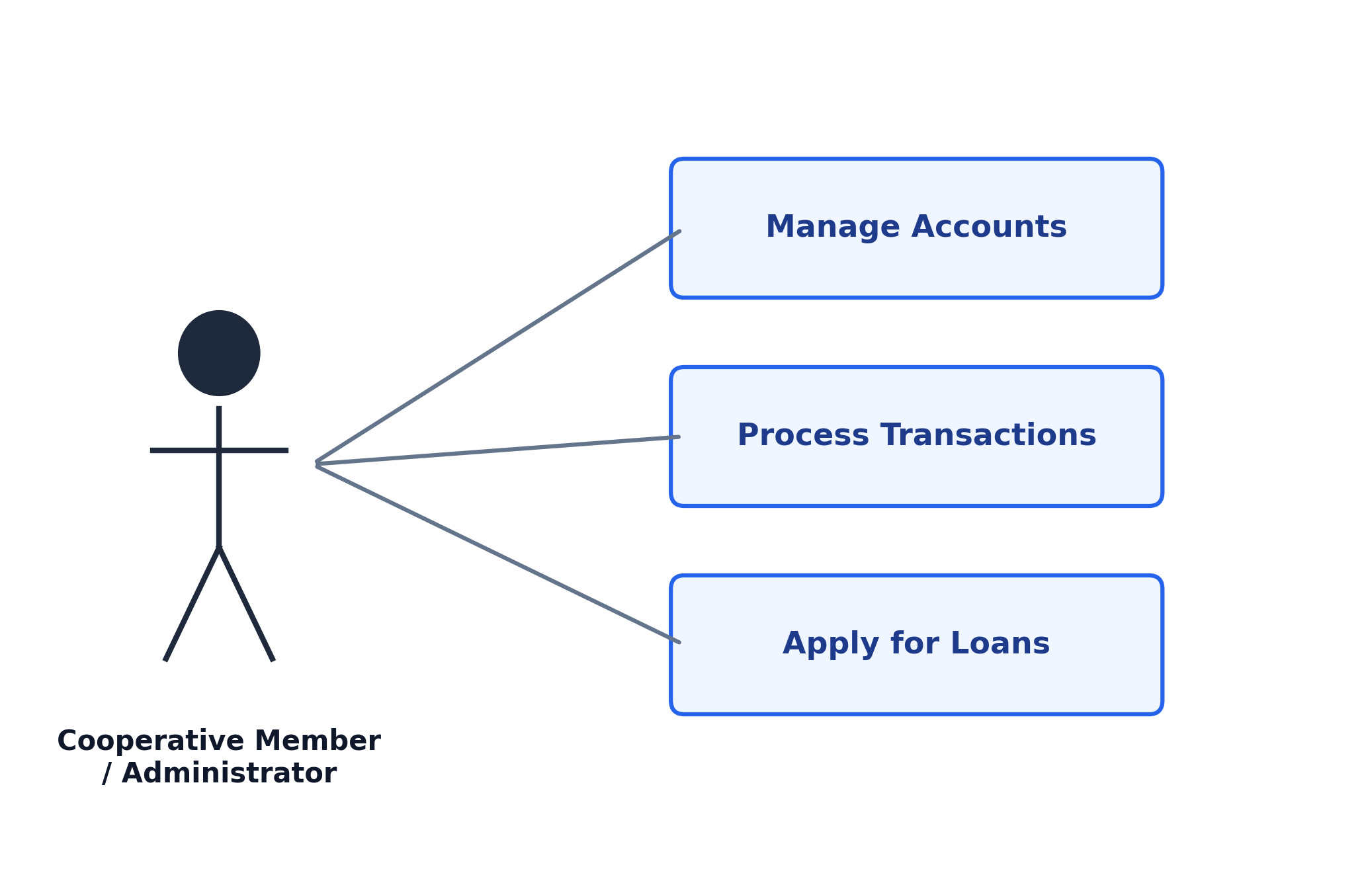
The Use Case Diagram illustrates how users interact with the FinCoop system. It identifies the system actors, their responsibilities, and the services available to each user, including member registration, transaction processing, loan management, and report generation. This diagram defines the system boundary and functional requirements (Pressman & Maxim, 2020).
Class Diagram
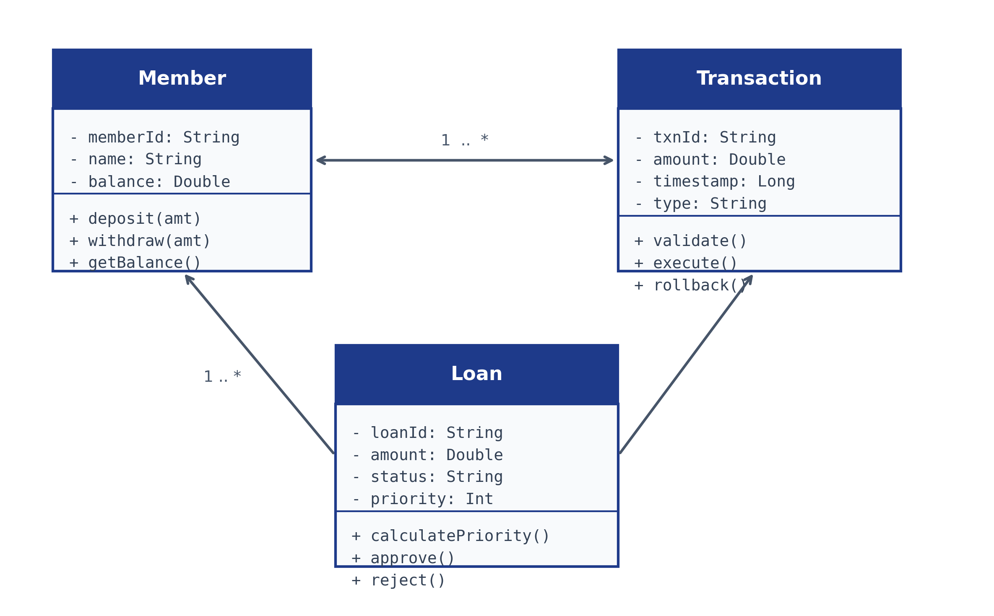
The Class Diagram represents the static structure of the system by identifying the major classes, their attributes, methods, and relationships. It demonstrates how system objects collaborate to manage financial transactions and member information using object-oriented principles (Sommerville, 2016).

Sequence Diagram
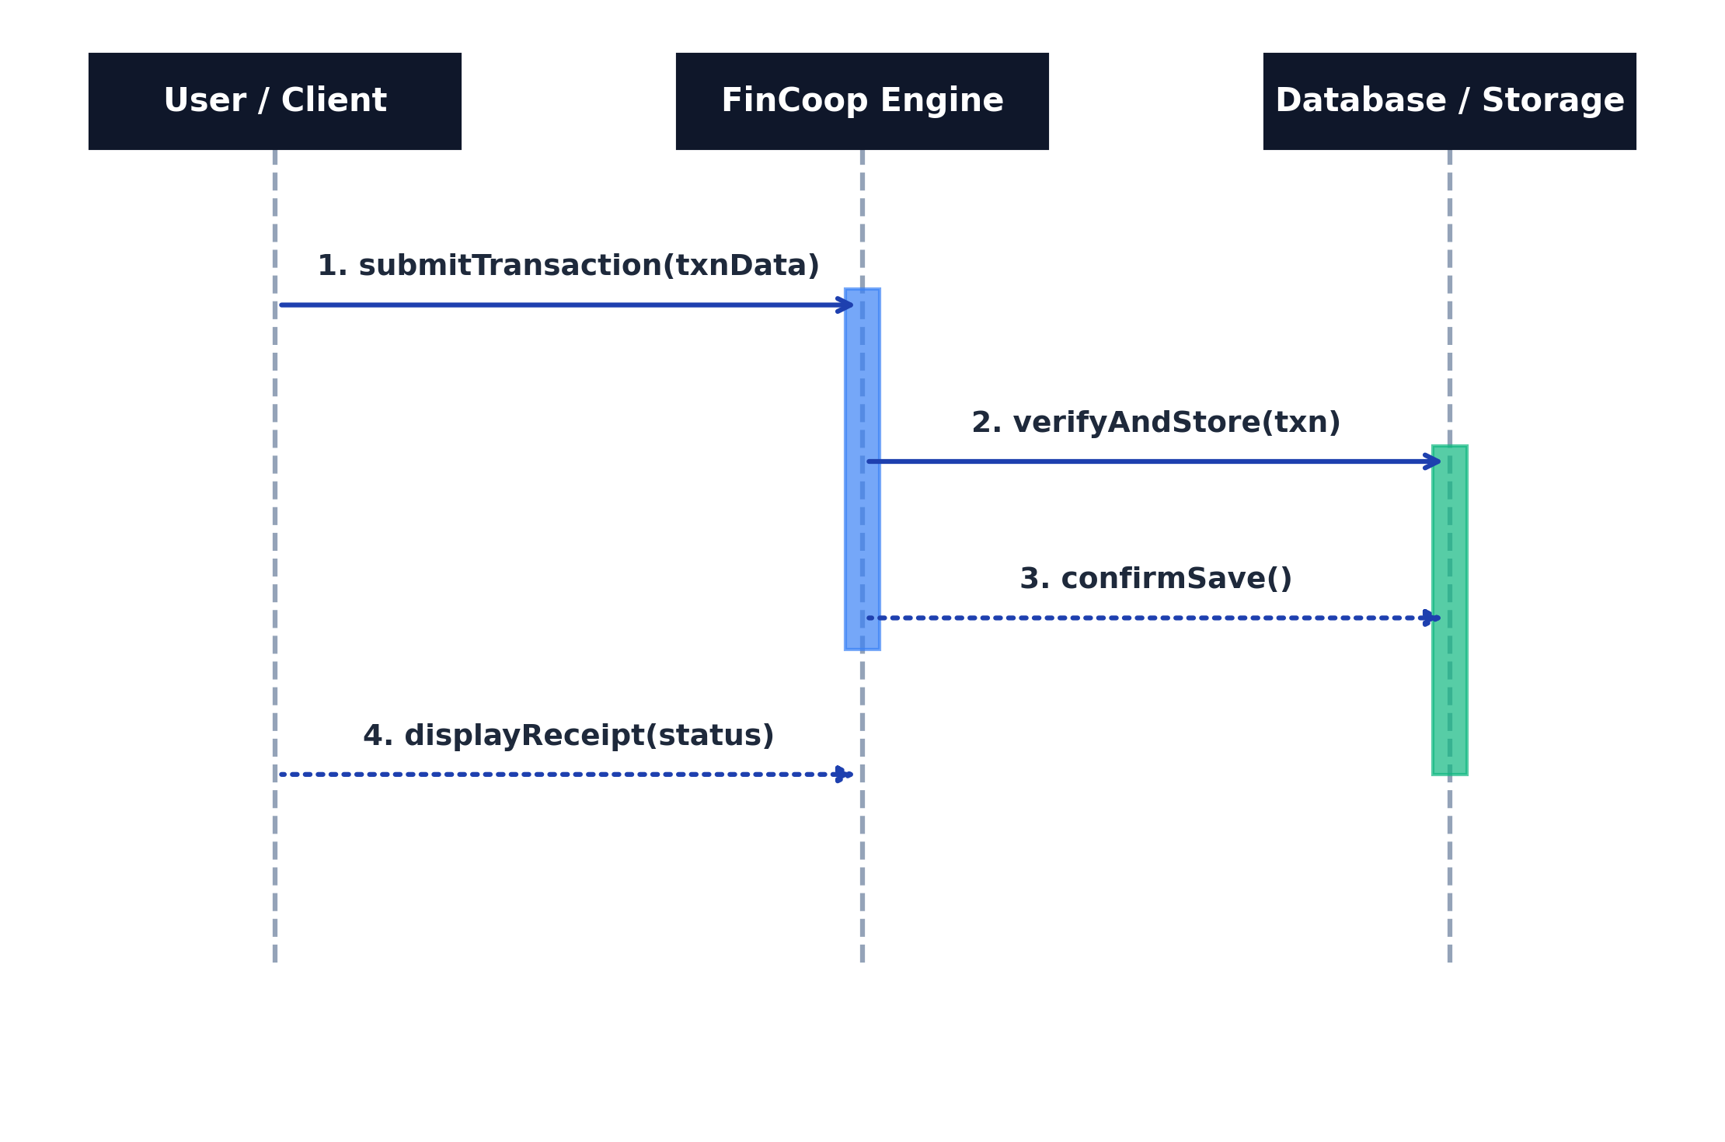
The Sequence Diagram illustrates the chronological flow of messages exchanged among users, system components, business logic, and the database during transaction processing. It demonstrates how financial transactions move through the system from initiation to completion (Pressman & Maxim, 2020).

Activity Diagram
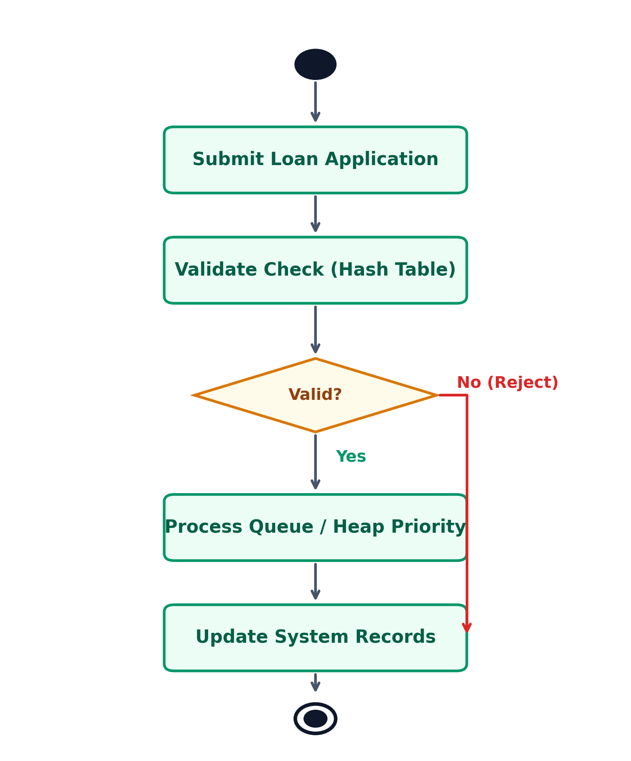
The Activity Diagram models the workflow of financial operations such as deposits, withdrawals, and loan approvals. It highlights decision points, validations, processing stages, and completion of activities within the system (Sommerville, 2016).

Architecture Diagram
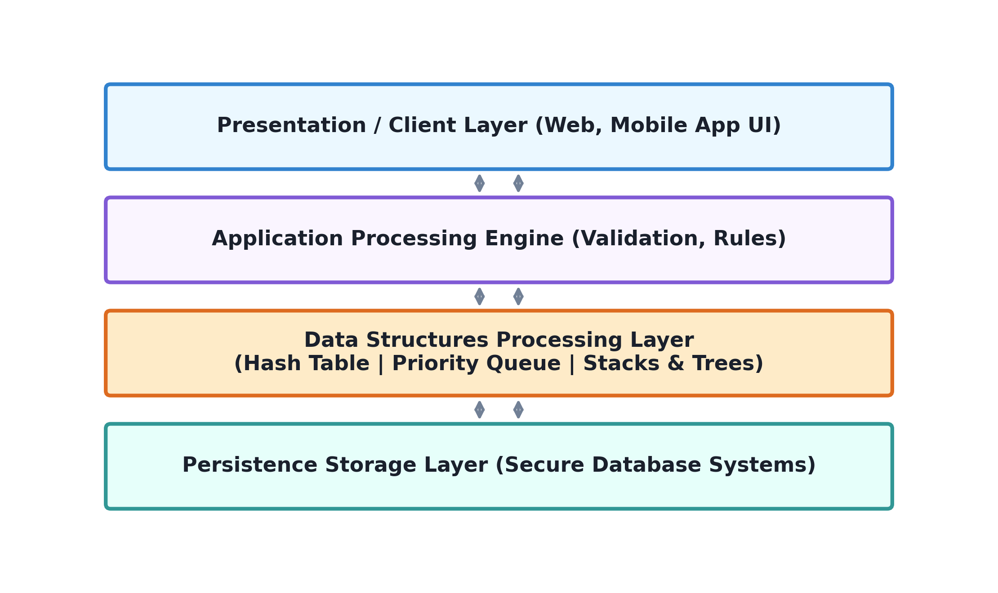

The Architecture Diagram illustrates the interaction between the presentation layer, business logic layer, data structures layer, and database layer. It demonstrates the modular organization of the FinCoop system and the communication among system components (Bass et al., 2022).

Entity Relationship Diagram (ERD)
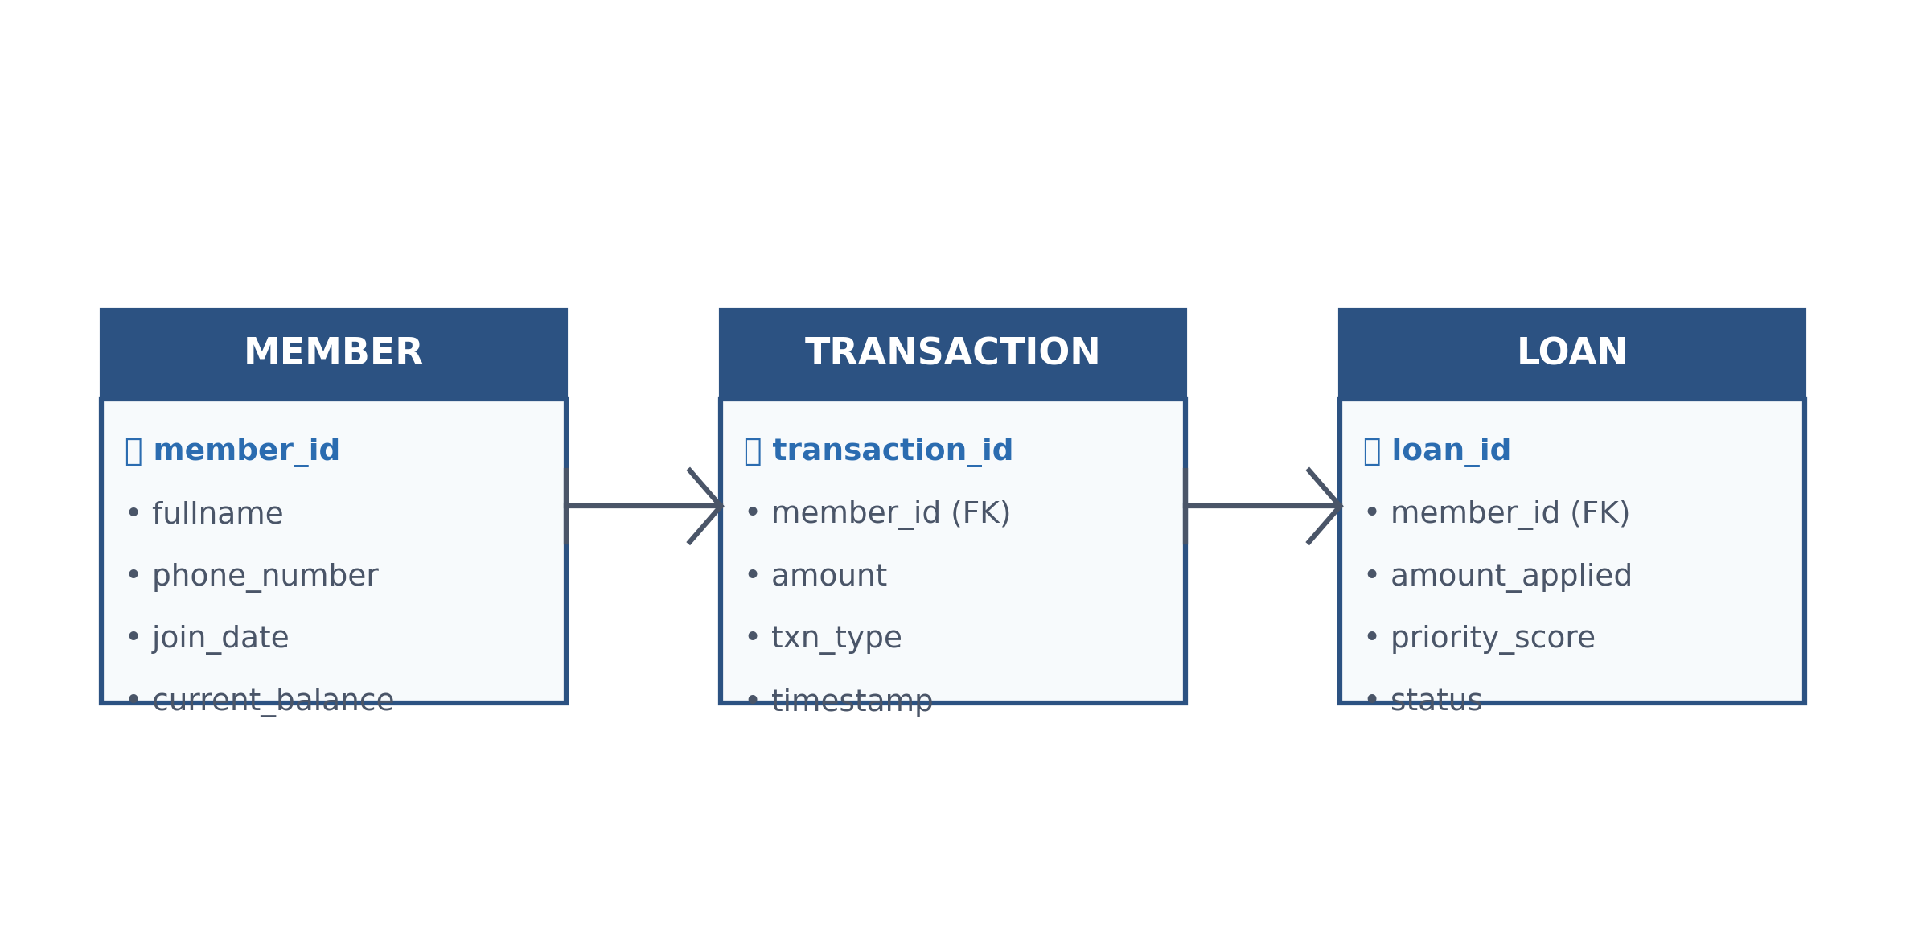
The Entity Relationship Diagram illustrates the logical structure of the database by identifying entities such as Members, Transactions, Accounts, Loans, and Reports together with their relationships, primary keys, and foreign keys. The ERD minimizes redundancy while ensuring data integrity (Elmasri & Navathe, 2017).

Data Flow Diagram (DFD)
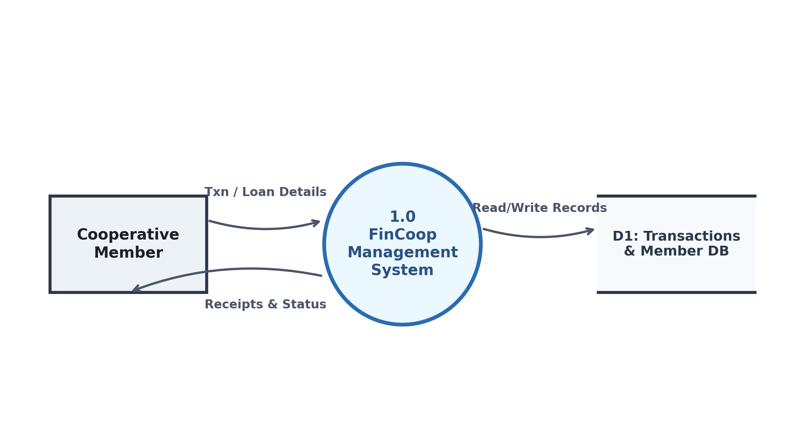

The Data Flow Diagram illustrates how information moves through the FinCoop system by identifying data inputs, processing activities, storage locations, and generated outputs. It provides a clear representation of how financial information flows between users, processes, and the database (Pressman & Maxim, 2020).

REFERENCES

Weiss, M. A. (2013). Data structures and algorithm analysis in C++ (4th ed.). Pearson.
Bass, L., Clements, P., & Kazman, R. (2022). Software architecture in practice (4th ed.). Addison-Wesley.
Cormen, T. H., Leiserson, C. E., Rivest, R. L., & Stein, C. (2022). Introduction to algorithms (4th ed.). MIT Press.
Elmasri, R., & Navathe, S. B. (2017). Fundamentals of database systems (7th ed.). Pearson.
Goodrich, M. T., Tamassia, R., & Goldwasser, M. H. (2014). Data structures and algorithms in Python. Wiley.
Pressman, R. S., & Maxim, B. R. (2020). Software engineering: A practitioner's approach (9th ed.). McGraw-Hill Education.
Sommerville, I. (2016). Software engineering (10th ed.). Pearson.
Weiss, M. A. (2013). Data structures and algorithm analysis in C++ (4th ed.). Pearson.

